
UNIT 3BCHE

OXIDATION & REDUCTION 2011

NAME: TIME ALLOWED: 60 MINUTES

Section One: Multiple Choice Questions. (10 marks)

1. Which of the following represents a balanced reduction half-reaction?

A. VO₂⁺ + H⁺ + 2e– → VO²⁺ + H₂O
B. VO₂⁺ + H₂ → VO²⁺ + H₂O + e–
#C. VO₂⁺ + 2H⁺ + e– → VO²⁺ + H₂O
D. VO₂⁺ + 4H⁺ + 3e– → VO²⁺ + 2H₂O

2. The dichromate ion Cr₂O₇^{2–} is orange in aqueous solution whereas Cr³⁺ is deep green. An acidified solution of potassium dichromate is thus a useful reagent for identifying many chemical species.

The following four aqueous solutions were prepared, and a few drops of acidified potassium
dichromate solution were added to each one. Two of them turned green; one turned a murky brown colour, and one remained orange.
Which solution remained orange?

A. FeCl₂
B. KI
C. CH₃CH₂OH
#D. Al₂(SO₄)₃

3. The following two unbalanced equations represent processes which are part of the nitrogen cycle.
I NH_{3(aq)} → NH₄⁺_{(aq)}
II NH₄⁺_{(aq)} → NO₃⁻_{(aq)}
Which one of the following alternatives correctly describes the reactants in each of these processes?

In process I, NH₃ _{(aq)} is In process II, the NH₄⁺ _{(aq)} ion is

A. an acid reduced
B. a base reduced
C. an acid oxidised
#D. a base oxidised
4. Which one of the following reactions shows sulfuric acid acting as an oxidising agent?

A. H₂SO_{4(aq)} + ZnCO_{3(s)} → ZnSO_{4(aq)} + CO_{2(g)} + H₂O_{(l)}
#B. 5H₂SO_{4(aq)} + 4Zn_{(s)} → H₂S_{(g)} + 4ZnSO_{4(aq)} + 4H₂O_{(l)}
C. 3H₂SO_{4(aq)} + Fe₂O_{3(s)} → Fe₂(SO₄)_{3(aq)} + 3H₂O_{(l)}
D. H₂SO_{4(l)} + SO_{3(g)} → H₂S₂O_{7(l)}

5. Which of the following transformations can only be achieved with a reductant?

#A. chlorine molecules → chloride ions
B. hydrogen molecules → water molecules
C. iron atoms → iron(II) ions
D. iodide ions → iodine molecules

6. Information supplied on the electrochemical series about Fe²⁺_{(aq)} indicates that Fe²⁺_{(aq)}

A. can act an oxidant but not a reductant.
B. can act as a reductant but not an oxidant.
#C. can oxidise solid zinc and reduce liquid bromine.
D. will always react to form Fe_{(s)} in redox reactions.

7. The diagram shows a galvanic cell.
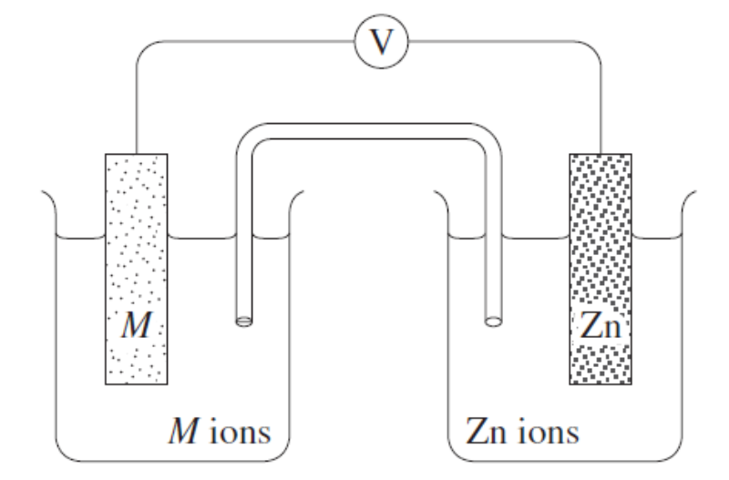
Which of the following metals (M) acting as an anode would produce the lowest
theoretical potential for the cell?

A. Calcium
B. Copper
C. Iron
#D. Manganese.
8. Many reactions occurring in plant and animal cells involve a chemical called nicotinamide adenine dinucleotide, NAD+. One such reaction is

2NADH_{(aq)} + 2H⁺_{(aq)} + O_{2(g)} 2NAD⁺_{(aq)} + 2H₂O_{(l)}

It has been suggested that this reaction could be used in biochemical fuel cells to power pacemakers used to control irregular heartbeats.
If this reaction were performed in a fuel cell, NADH would

#A. undergo oxidation at the anode.
B. undergo reduction at the cathode.
C. undergo reduction at the anode.
D. undergo oxidation at the cathode.

9. Two standard galvanic cells are shown below.
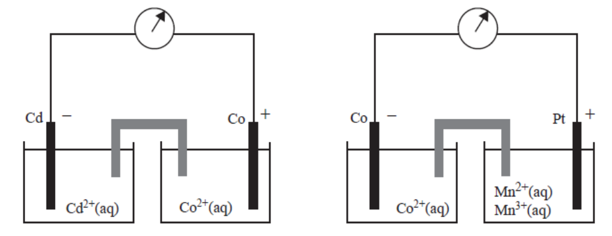
On the basis of the polarity of the electrodes shown above, which one of the following reactions would not be expected to occur spontaneously?

A. Co²⁺_{(aq)} + Cd_{(s)} → Co_{(s)} + Cd²⁺_{(aq)}
B. 2Mn³⁺_{(aq)} + Co_{(s)} → 2Mn²⁺_{(aq)} + Co²⁺_{(aq)}
C. 2Mn³⁺_{(aq)} + Cd_{(s)} → 2Mn²⁺_{(aq)} + Cd²⁺_{(aq)}
#D. 2Mn²⁺_{(aq)} + Co²⁺_{(aq)} → 2Mn³⁺_{(aq)} + Co_{(s)}

10. The following is a list of selected standard reduction potentials:

Cd²⁺ _{(aq)} + 2e– Cd _{(s)} E⁰ = −0.40 V
Zn²⁺ _{(aq)} + 2e– Zn _{(s)} E⁰ = −0.76 V
Ni²⁺ _{(aq)} + 2e– Ni _{(s)} E⁰ = −0.23 V
By referring to the standard reduction potentials above, which of the following species is the best oxidizing agent?

#A. Ni²⁺ _{(aq)}
B. Zn _{(s)}
C. Cd _{(s)}
D. Zn²⁺ _{(aq)}
End of Section One
Section Two: Short Answer Questions (15 marks)

11. Transition metal ions are often brightly coloured and can exist in a wide range of oxidation states.
Vanadium is particularly diverse: an oft-used chemistry demonstration involves swirling a
vanadium(V) solution with zinc in a flask, which causes the solution to change colour from yellow to blue to green and finally, pale violet.

A. Complete the following table for the oxidation states.

Species | Colour | Oxidation State
V _{(s)} | Silver/grey | 0
V²⁺ _{(aq)} | pale violet | +2
V³⁺ _{(aq)} | green
VO²⁺ _{(aq)} | deep blue
VO₃– _{(aq)} | yellow
3 marks

The vanadous ion (V²⁺) is used in a redox titration to determine the concentration of an unknown solution containing the Fe³⁺ ion. Iron(III) is reduced to iron(II), and the solution is acidic throughout the determination.

B. Write the two half equations and the balanced full equation for this reaction? The first one has been done for you.

V²⁺ → V³⁺ + e–

2 marks

Fiona, an earnest young analytical chemist, decided to make some 0.500 mol L^{–1} vanadous sulfate (VSO₄) solution. She had a bottle of vanadyl sulfate (VOSO₄.2H₂O), which she stirred with an excess of zinc metal (amalgamated with a small amount of mercury(II) catalyst).

Since it was getting late, Fiona decided to filter the solution and leave it out on the bench, with the intention to perform the titration the next day. Disaster struck! Fiona returned to find her perfectly prepared pale violet solution had a slight green tinge.

C. Write a possible equation for the reaction of the V²⁺ ion with air.

2 marks
12. An electrochemical cell is set up using the lead and copper standard half cells.

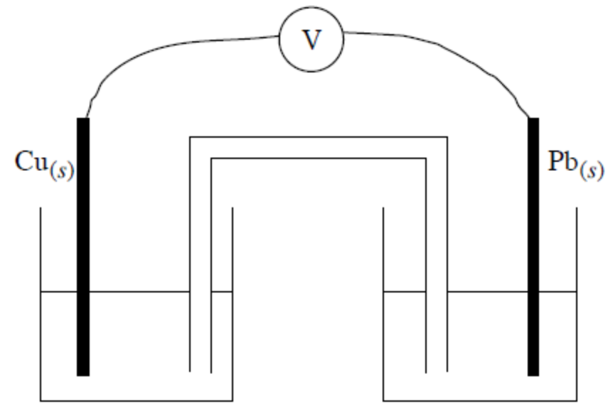

A. On the diagram above label the electrodes as positive or negative. 1 mark
B. On the diagram above label the anode and cathode. 1 mark
C. On the diagram show the direction of the electron flow. 1 mark
D. On the diagram show the movement of ions through the salt bridge. 1 mark
E. Give the name of a suitable chemical for the salt bridge.

1 mark

F. Give the names of suitable chemicals for the two ½ cells.

1 mark

G. Write the cell reaction and calculate the overall voltage for the above cell.

2 marks
Section Two: Extended Answer Questions (15 marks)
13. One of the earliest examples of marine corrosion occurred in the eighteenth century on the
British Navy battleship H.M.S. Alarm. The vessel had its wooden hull covered by copper
sheeting, which was fastened by iron nails. Not surprisingly the iron nails corroded rapidly
and some copper sheeting fell off the hull.

A. Explain, using the principles of electrochemistry, why the corrosion took place.
4 marks

B. Why do you think the iron nails corroded so rapidly? 2 marks

C. How might the corrosion have been prevented? 2 marks

THIS QUESTION CONTINUED OVERLEAF
D. The amount of iron in a newly developed, heat-resistant aluminium alloy is to be determined.

80.50 g sample of alloy is dissolved in concentrated sulfuric acid and the iron atoms are converted to Fe²⁺_{(aq)} ions.

This solution is accurately transferred to a 250.0 mL volumetric flask and made up to the mark.
20.00 mL aliquots of this solution are then titrated against a standard 0.0400 molL⁻¹ potassium permanganate solution.

Four titrations were carried out and the volumes of potassium permanganate solution used were recorded in the table below.

Titration number | 1 | 2 | 3 | 4
Volume of KMnO₄ (mL) | 22.03 | 20.25 | 21.97 | 21.99

Write a balanced net ionic equation for the reaction of potassium permanganate with
the Fe²⁺_{(aq)} ions.

1 mark
Calculate the mean titre of the potassium permanganate solution.

1 mark

Calculate the amount, in mol, of MnO₄⁻_{(aq)} ions used in this titration..

1 mark

Calculate the amount, in mol, of Fe²⁺_{(aq)} ions present in the 250.0 mL volumetric flask.

2 marks

Calculate the percentage, by mass, of iron in the 80.50 g sample of alloy.
Express your answer to 3 significant figures.

2 marks

END OF LAST TEST
GOOD LUCK IN THE MOCKS (35 ÷ 2 = 17.5%)
AND ONWARD TO THE WACE EXAM ITSELF (100 ÷ 2 = 50%)
UNIT3BCHE SOLUTIONS

OXIDATION AND REDUCTION 2011: Answer all questions

Section One: MULTIPLE CHOICE QUESTIONS (10 marks)

1C | 2D | 3D | 4B | 5A | 6C | 7D | 8A | 9D | 10A

Section Two: Short Answer Questions (15 marks)

11.
A.
V³⁺ _{(aq)} | green | +3
VO²⁺ _{(aq)} | deep blue | +4
VO₃– _{(aq)} | yellow | +5
3 X 1 mark

B. Fe³⁺ + e⁻ → Fe²⁺ 1 mark
V²⁺ + Fe³⁺ → V³⁺ + Fe²⁺ 1 mark

C. V²⁺ → V³⁺ + e⁻ (responsible for green)
O₂ + 2H₂O + 4e⁻ → 4OH⁻ (oxygen from air) 1 mark
4V²⁺ + O₂ + 2H₂O → 4V³⁺ + 4OH⁻ 1 mark
12.
A. B. C. & D. 4 x 1 mark
E. aqueous ammonium nitrate or potassium nitrate 1 mark
F. aqueous copper and lead nitrate 1 mark
G. Pb_{(s)} + Cu²⁺_{(aq)} → Cu_{(s)} + Pb²⁺_{(aq)} 1 mark
E⁰ = +0.13 + (+0.34) = + 0.47 V 1 mark
13.
A. An electrical potential difference is set up between the metals. Attaching an unreactive metal such as Cu to Fe enhances corrosion.
1 mark

The iron acts as the anode, and iron undergoes oxidation (corrosion). The iron pushes its electrons onto the copper where reduction takes place. (Metals cannot undergo reduction and it is the O₂ in the H₂O which undergoes reduction)
1 mark

2Fe_{(S)} + O_{2(g)} + 2H₂O → 2Fe²⁺_{(aq)} + 4OH⁻_{(aq)} 1 mark

E⁰ = 0.44 + (+0.40) = + 0.84 V
The +ve E⁰ indicates that this process is a spontaneous one. 1 mark

B. The salt (water) contains ions 1 mark

The presence of these ions increases the conductivity (electrolyte) thus enhancing the corrosion.
1 mark

C. Use copper nails 1 mark
as they do not corrode. 1 mark

D. 5Fe²⁺_{(aq)} + MnO₄⁻_{(aq)} + 8H⁺_{(aq)} = 5Fe³⁺_{(aq)} + Mn²⁺_{(aq)} + 4H₂O_{(l)} 1 mark

mean titre = (21.97 + 21.99) ÷ 2 = 21.98 mL 1 mark

n(MnO₄⁻) = cV = 0.0400 x 0.02198 = 0.0008792 mol 1 mark

n(Fe²⁺)_{in 20 mL} = 5 x n(MnO₄⁻) = 5 x 0.0008792 = 0.004396 mol 1 mark
n(Fe²⁺)_{in 250 mL} = 0.004396 ÷ 20 x 250 = 0.05495 mol 1 mark

m(Fe) = n x M = 0.05495 x 55.85 g = 3.068 g 1 mark

%(Fe) = m(Fe) ÷ m(alloy) x 100%
= 3.068 ÷ 80.50 x 100 = 3.81 % 1 mark

